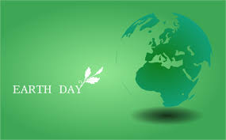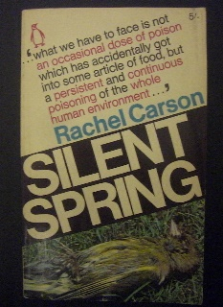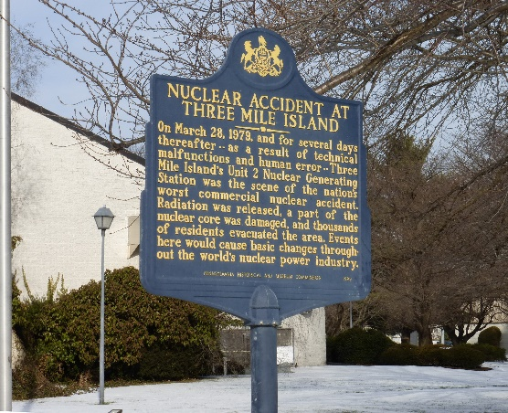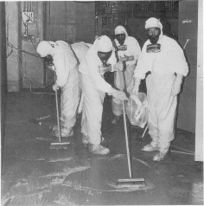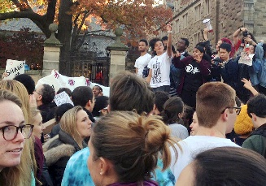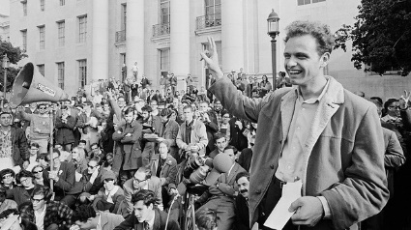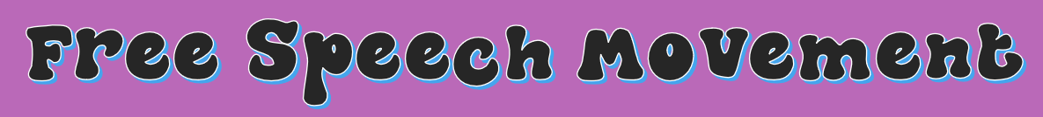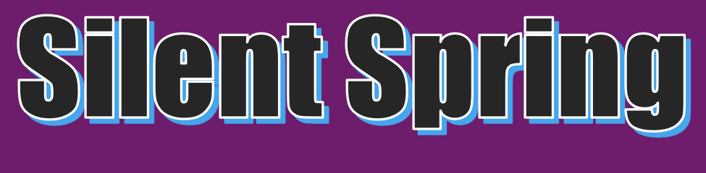

***Silent Spring* was a book written by marine biologist Rachel Carson. Carson wrote the book about the United State’s increasing use of pesticides in agriculture. She wrote that the pesticides do their jobs in killing insects, but they also kill local birds, fish and other creatures. She speculated a “Silent Spring” in the near future, where all the birds had been killed by the human use of pesticides.**

* **This book began the environmental movement, which resulted in increased awareness of human’s effect on the environment**
* **The environmental movement ended up causing Nixon to start the EPA, which currently protects the United State’s environmental footprint.**
* **This event halted United State’s participation in nuclear energy for years after, causing us to be behind in the nuclear industry.**
* **This event also caused people to doubt the possibility of a fully nuclear PowerGrid.**
* **The Movement affects us today because Universities can no longer prohibit gatherings or first amendment rights.**
* **It also affects us by showing effective ways to protest at university that are still used.**

**The Three Mile Island Incident was a partial nuclear meltdown that happened in 1979. The plant’s cooling system failed, allowing the reactor to overheat. Some radioactive material escaped, but it was cleaned up. The accident forced nearby citizens to evacuate, which resulted in protest after the event.**

**The Free Speech Movement was fighting for first amendment rights at the University of Berkeley. School Administrators had decided to place restrictions on their student’s rights to distribute pamphlets and other literature, as well as their ability to protest on school grounds. Police were called by the Governor, and over 700 students were arrested for their protest. Eventually, the supreme court ruled in favor of the students.**